**Lab - 8**

**Shape Feature Extraction and GLCM**

**Priyanshu Sharma**

**15BCE1282**

**Question - Load test image TPTest1.png and display its contents.**

**Code -**

clc

clear all

a = imread('C:\Users\PRIYANSHU SHARMA\Desktop\PRIYANSHU\6 STUDY\MATLAB\LAB 8\1.png');

imshow(a)

a = im2bw(a,graythresh(a));

[B,L] = bwboundaries(a);

figure, imshow(a);

hold on;

for k=1:length(B)

boundary = B{k};

plot(boundary(:,2),boundary(:,1),'g','LineWidth',2);

end

[L, N] = bwlabel(a);

RGB = label2rgb(L, 'hsv', [.5 .5 .5], 'shuffle');

figure, imshow(RGB);

hold on;

for k=1:length(B)

boundary = B{k};

plot(boundary(:,2),boundary(:,1),'w','LineWidth',2);

text(boundary(1,2)-11,boundary(1,1)+11,num2str(k),'Color','y','FontSize',14,'FontWeight','bold');

end

stats = regionprops(L,'all');

temp = zeros(1,N);

for k = 1:N

temp(k) = 4*pi*stats(k,1).Area / (stats(k,1).Perimeter)^2;

stats(k,1).ThinnessRatio = temp(k);

temp(k) = (stats(k,1).BoundingBox(3))/(stats(k,1).BoundingBox(4));

stats(k,1).AspectRatio = temp(k);

end

areas = zeros(1,N);

for k=1:N

areas(k) = stats(k).Area;

end

TR = zeros(1,N);

for k = 1:N

TR(k) = stats(k).ThinnessRatio;

end

cmap = colormap(lines(16))

for k = 1:N

scatter(areas(k), TR(k), [], cmap(k,:), 'filled'), ylabel('Thinness Ratio'), xlabel('Area')

hold on

end

**Result**

Cmap =

0 0.4470 0.7410

0.8500 0.3250 0.0980

0.9290 0.6940 0.1250

0.4940 0.1840 0.5560

0.4660 0.6740 0.1880

0.3010 0.7450 0.9330

0.6350 0.0780 0.1840

0 0.4470 0.7410

0.8500 0.3250 0.0980

0.9290 0.6940 0.1250

0.4940 0.1840 0.5560

0.4660 0.6740 0.1880

0.3010 0.7450 0.9330

0.6350 0.0780 0.1840

0 0.4470 0.7410

0.8500 0.3250 0.0980

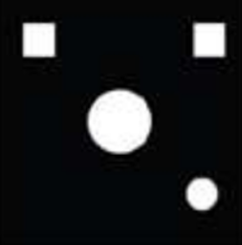

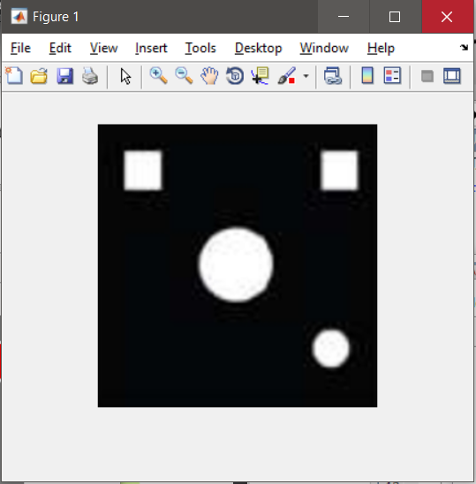

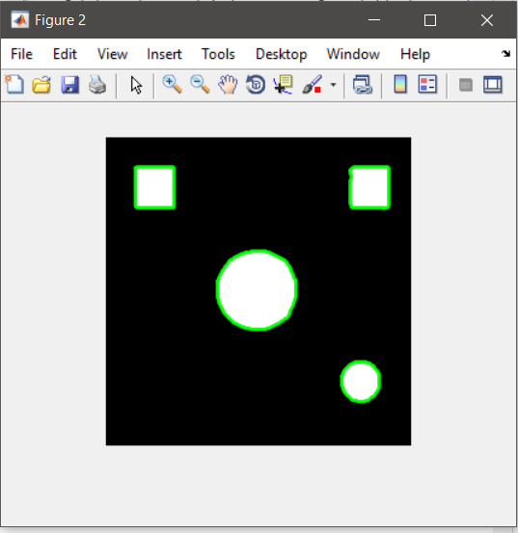

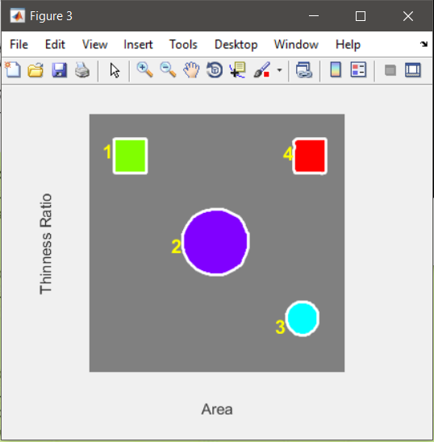

**Question 1 What is the value of N returned by bwlabel? Does it make sense to you?**

**ANS:** N = 4

Organize the feature values and object names in a table (see Table 18.5), for easier comparative analysis.

|  |  |  |  |  |  |  |  |  |
| --- | --- | --- | --- | --- | --- | --- | --- | --- |
| **Object** | **Area** | **Centroid** | **Orientation** | **Euler Number** | **Eccentricity** | **Aspect Ratio** | **Perimeter** | **Thinness Ratio** |
| **Top left Square** | 750 | [30.9653333333333,27.5000000000000] | -90 | 1 | 0.266673612456936 | 0.964285714285714 | 100.754000000000 | 0.928424374104298 |
| **Big Circle** | 2205 | [97.9632653061225,95.5505668934240] | 13.2176558718481 | 1 | 0.0923589348046220 | 1 | 164.345000000000 | 1.02590103123502 |
| **Small Circle** | 556 | [166.273381294964,155.780575539568] | 85.8403897331540 | 1 | 0.310330243714598 | 0.962962962962963 | 80.9820000000000 | 1.06538765230792 |
| **Top right square** | 722 | [172.498614958449,27.5013850415512] | 87.2192143425302 | 1 | 0.371770144498667 | 0.928571428571429 | 98.7940000000000 | 0.929578182931636 |

**Question 2 Do the results obtained for the extracted features correspond to your expectations? Explain.**

**ANS:** Yes, the results obtained from the extracted features do correspond to our expectations as the they are able to bound all the objects inside the given image and also gives the area, perimeter, centroid, etc..

**Question 3 Which of the extracted features have the best discriminative power to help tell squares from circles? Explain.**

**ANS:** The feature to discriminate between the circles and the square is eccentricity as it means deviation of a curve or orbit from circularity.

**Question 4 Which of the extracted features have the worst discriminative power to help tell squares from circles? Explain.**

**ANS:** Euler number, the Euler number is a measure of the topology of an image. It is defined as the total number of objects in the image minus the number of holes in those objects.

**Question 5 Which of the extracted features are ST invariant, that is, robust to changes in size and translation? Explain.**

**ANS:** Centroid will always be robust to changes in size and translation as the center of any object of any size if increased or decreased always remains the same.

Eccentricity could also be used as it robust to changes in size and translation.

**Question 6 If you had to use only one feature to distinguish squares from circles, in a ST invariant way, which feature would you use? Why?**

**ANS:** Eccentricity is invariant of any changes in sizes or translations.

**Question - Write a MATLAB program to compute the gray-level co-occurrence matrix for an image f (x, y) and a displacement vector d, which should be passed as parameters.**

CODE:

function glcm=exercise2(path,d)

%path is path of image

%d is displacement vector

clc

J=imread(path);

J=im2bw(J,graythresh(J));

[m,n]=size(J);

glcm=zeros(2,2);

for i=1:m

for j=1:n-1

if (J(i,j)==0 && J(i,j+d)==0)

glcm(1,1)=glcm(1,1)+1;

end

if (J(i,j)==0 && J(i,j+d)==1)

glcm(1,2)=glcm(1,2)+1;

end

if (J(i,j)==1 && J(i,j+d)==0)

glcm(2,1)=glcm(2,1)+1;

end

if (J(i,j)==1 && J(i,j+d)==1)

glcm(2,2)=glcm(2,2)+1;

end

end

end

CALL:

clc

clear all

close all

glcm = 'C:\Users\TEMP\Desktop\snap2.png';

GLCMFeatures(glcm, 1)

**RESULT**

